|  |  |  |
| --- | --- | --- |
|  | Survey Analysis Document | |
| 8/23/2013 | Graduate Capstone |  |

Table of Contents

1 Introduction 3

1.1 Intended Audience 3

1.2 References 3

1.3 Revision History 3

2.1 Goals as a Business 4

2.2 Analytics 5

2.2.1 Surveys 5

2.2.2 Transactions 6

3.1 Websites 6

3.2 Types of Questions 6

3.2.1 Demographics 7

3.2.2 Ratings 7

3.2.3 Categorical 7

3.2.4 Locational and Time 8

3.2.5 Contact 8

3.3 Flows 8

3.3.1 Static 8

3.3.2 Dynamic 9

4.1 The Goal 10

4.2 Reverse Engineering 10

5.1 Surveys 11

5.2 Revisions 11

5.3 Questions 13

5.4 Forms and Automations 15

5.5 Form Flows and Automation Flows 15

5.6 Form Elements 16

5.6.1 Form Element Attributes 16

5.6.2 Form Element Options 16

5.7 Command Elements 19

5.7.1 Identifier 19

5.7.2 Form Element Relation 20

8.1 Required Fields 21

8.2 Validation of Data 21

8.2.1 Numerical 21

8.2.2 Range 21

8.2.3 Is one of / is not one of 22

8.2.4 Format 22

# 1 Introduction

The purpose of this document is to explain and give an in depth analysis on the structure, design and make up of Company Survey Websites. By doing so, this will give a great understanding to the complexity involved with having to re-create these surveys in the system.

## 1.1 Intended Audience

This document is intended for persons trying to understand the fundamental business side of how survey work for this project. The goal is for those individuals to learn about the surveys and learn what is involved to recreate the surveys in the system.

## 1.2 References

No references were used.

## 1.3 Revision History

Managing the change history of this document will occur in this table.

|  |  |  |  |
| --- | --- | --- | --- |
| Name | Date | Reason For Change | Version |
| Andy Bottom | 08/08/2013 | Created the introduction and parts of the document. | 0.1 |

2 Company Perspective

This section will talk about the business side of what the purposes of the surveys are.

## 2.1 Goals as a Business

For any business, the goal is to be able to make a profit. By doing so, businesses sell something and in return are paid. Now the variety of what a company may vary greatly including, (ex. products, services, etc…) but they do sell them to their customers.

The ability of increase their sales typically depends on several factors. The first is that they have a quality product that people want and serves a need in the marketplace. However having a great product unfortunately is not all that it takes to make the sales. A bit of advertising, marketing and strategic targeting are also very important to get the word out about your company.

So how do you determine whether or not the success of the sales. This first obviously would be profitability, and ensuring that the company is actually making money. But the second is the satisfaction of the consumer.

The consumer is what you’re entire business is depended on, and when it comes down to it, if you have no consumer then you can’t stay in business. So the successfulness of you company is to meet the needs of you client. Their satisfaction with the product and the overall experience is what will make them come back to your business and hopefully return to and returning loyal customer and in turn, a larger customer base through word of mouth.

## 2.2 Analytics

The ability to target you clientele puts you at a huge advantage as a business. In fact, this is the reason many businesses deciding on investing in analytics for the purpose to do just this.

Analytics has certainly grown exponentially over the decades with newer, cheaper, accessible software has become available.

So with analytics, you perform analysis on data and recognize trends, costs, and feedback. Once this analysis, you can make changes and responded quickly to remain competitive and continue targeting you customer base.

### 2.2.1 Surveys

Data can be gathered from a variety of places. You can identify what products have been selling and collect the data in that way. But by doing it this way, the results will only contain data about the product. Again, going back to the original point, you could have the best product ever, but without a customer base, it won’t make a sale. Reminds me of the famous quote, “If you build it, they will come,” which happens to be not as true as it may seem. So, one must collect data about the customer in order to identify who the customer is and how to target them.

Typically, to collect data about the customer, you would usually create surveys to get the user to fill out. However, we have gotten very bogged down with companies trying to get our information and fill out surveys that we now feel that it is a waste of our time.

So to combat this, businesses must create an incentive for the customers to fill out surveys, thus they give out a reward for taking time to fill out the survey. This then creates the balance for the customer to fill out the survey and get the reward that they want and the user to obtain the valuable data about the customer. This is the win-win situation for all parties.

### 2.2.2 Transactions

During transactions, it has been commonality that with all purchases and transactions for there to be a receipt that they customer receives to show proof of purchase. Since the receipt is already given to the customer already, it has become practice to conveniently advertise their survey at the bottom of the receipts for the customer to see and then take action.

3 Satisfaction Surveys

This section will break down the typical flow of the survey websites.

## 3.1 Websites

Originally, satisfaction and feedback forms were more of a formality that customers, if they choose, could write down feedback and submit it for the managers to be able to read and respond to if need be. There wasn’t any underlying need of the business other than help the customer out and respond to their requests. But now with the analytics, businesses are proactive in asking questions in the surveys to be able to obtain analytical data from the users. In addition, with the help of technology, all the surveys and feedback forms are now online on websites to provide an easier and faster way to extract the data and turn it into meaningful reports and act accordingly.

## 3.2 Types of Questions

As briefly mentioned above, almost all the questions on these surveys are designed so that it can be transformed into meaningful analytical data. These are broken down into three categories: Demographics, Ratings, Categorical, Locational, Time and Contact

### 3.2.1 Demographics

The demographic questions involve asking about quantitative details about oneself and who they are. This way, they are able to cluster people into groups and observe any similarities or correlations in the data in this way.

Typical questions that are asked about the person may include:

* Race / Ethnicity
* Age
* Gender
* Annual Income
* Zip Code / State

### 3.2.2 Ratings

The rating questions are used to observe feelings towards something via a scale of positive or negative. The scale may also be displayed as scales including: Numerical, Stars, etc… but always represented as positive or negative.

Questions using a ratings scale typically are used to determine the point-of-view of a person about their experience and the quality of something. Typical questions may include:

* Quality of the Environment
* Quality of the Product
* Friendliness of staff
* Overall Experience

### 3.2.3 Categorical

The categorical questions are similar to demographic questions in that they are used to combine people into groups in hopes of seeing similarities and patterns in the responses. If there are correlations, then it can be determined that the common factor may have an impact and depending on the impact should be removed or expanded upon.

### 3.2.4 Locational and Time

Location questions are typically asked for of the location visited the business. Time questions involve the date of the visit and the time period that they visited the locale. Also, there may be questions on how often the person visits the business.

### 3.2.5 Contact

Contact information is again asking about information directly from the person, but as opposed to demographics, contact questions are a way of getting information about how to contact you and perhaps market to the person about sales, promotions or etc… However, most surveys claim that they won’t use this information other than to have it.

Just to note: I’ve casually surveyed people and many felt uncomfortable about giving out contact information for this very reason of not wanting to get spammed by e-mails or phone calls from the company.

## 3.3 Flows

This section is used to explain how the flows of questions work.

### 3.3.1 Static

There are some surveys that take a very static flow of the questions. In this way, the questions are always in the same order and collected.

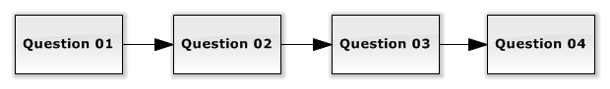

Figure 3.3.1-1

### 3.3.2 Dynamic

Dynamic flows differ from static flows in that the questions may vary depending on what responses were received from the customer.

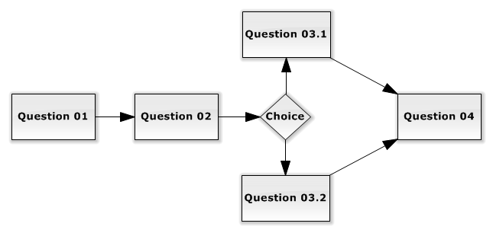 *Figure 3.3.2-1*

To give another example, on a restaurant survey, they may ask the question: Where did you place your order? Depending on what answer you gave, it will decide which flow you go through. As seen in *Figure 3.3.2-2.*

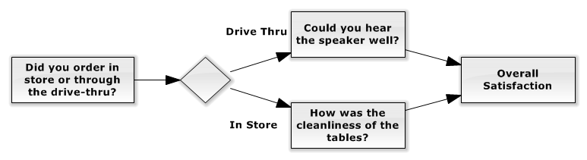

*Figure 3.3.2-2*

4 Managing the Data

In this section we will identify how we will get surveys from the Survey Websites into our application.

## 4.1 The Goal

So first, let just reiterate what the Receipt Rewards application will do. The user chooses the survey and we will display that survey to them on the phone. They fill it out and submit the answers. Then our Web Driver process will hit the Survey Website and in an automated process fill in the users answers into the form. At the end, we will obtain a reward or success message and return it back to the user. This is the base case.

## 4.2 Reverse Engineering

As we have stated earlier, it is clean that our entire application is completely independent from the Survey Websites. So how then do we go about adding the survey to our system?

Unfortunately there is no easy way to get the Website questions into our application, so thus a manual way needed to be created in order to create the surveys in our system. By doing this we will have a Web CMS site that an Administrator will use in order to recreate the survey.

5 Receipt Reward Surveys

In this section, we will discuss in depth the makeup of all the surveys. This section is extremely important in understanding all the relations involved with Surveys.

To view the realizations of the Objects that are being discussed, please see the **Database Diagram Document** and the **Software Design Document** for more details.

## 5.1 Surveys

All companies will have a survey attached to them. These surveys are the Satisfaction Surveys that our application is aimed to aid in completion for the user.

## 5.2 Revisions

Revisions are the next level under surveys. These represent the version of a survey. Most importantly, a revision creates the separation between the questions, forms and commands with the actual high-level Survey Object. This is very important for the following reason: If a company decides to make changes to their Satisfaction Survey Website, the may add, update or remove a question or reorder something. By doing this, all references of that prevision version of the survey may have updated all the elements and references of the elements ids could have changed, thus rendering our Web Driver Automation completely useless.

So whenever a survey has changed, we must make a new revision of that survey and recreate that survey for the new version. The reason that we create a new revision and not just update the existing revision is because that revision may have already had form_submissions associated to that revision. If we made changes to the revision, then that would create orphaned data of the form_submissions, and thus becomes problematic. Thus the new revision object leads itself to better data quality in the database by keeping preexisting relations intact. See Figure 5.2-1 for details.

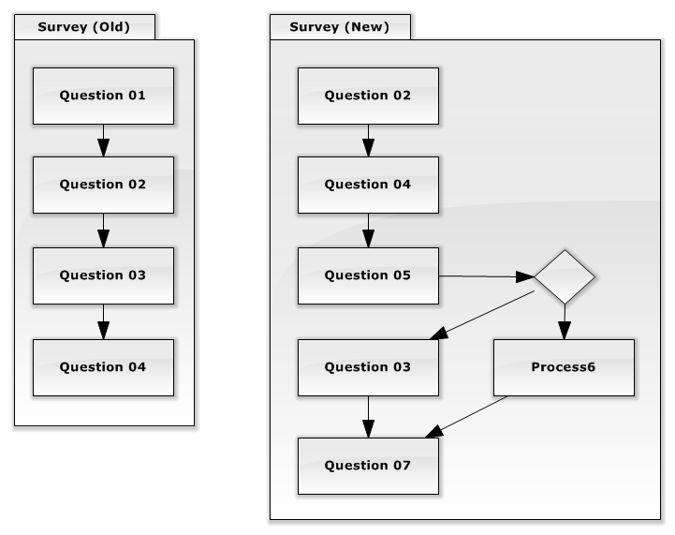

*Figure 5.2-1*

For example, let’s say that a company changes their survey. The original version is Survey Old in the diagram above. However, the new version is Survey New. As you can see, they removed Question 01, switched the order of Question 03 and Question 04. They also added Question 07 and Question 05. On Question 05, they added a multiple flow to Question 06.

Now the revision in our system would have looked exactly like Survey Old. In addition, all the submissions that were made had Question01 -04 as well. However, if we simply edited the revision to look like Survey New, then all the Submissions in our system would be rendered useless and wouldn’t be able to run since they don’t contain any new questions. Nor could we look at how it was changed since the Revision has been edited and no way to look at how it was. This is why we create a new revision whenever a company changes a survey so that we can preserve the historical information about the revisions.

## 5.3 Questions

Questions act independently as their own entity. The questions purpose is simply a container which holds one distinct form and distinct automation list. Questions provide the logical connection grouping between the form and automation. This grouping is needed because it allows for an easier logical understanding between the form and automation.

On surveys, the Question is a single question on a survey. Thus the form of the Question will contain the elements of that questions and the automation will have the commands needed to fill in that question during the automation process. Thus the conceptual link is made by putting both the form and automation inside a Question.

As stated earlier, there is a need to be able to have multiple flows for the questions. Depending on what the user answers may then lead to a different set of questions being asked. Thus the standard single relation would not be flexible enough to handle these types of associations. In addition to this, questions are always made up of two distinct halves.

Questions are referenced in two different contexts, in the Form displaying context and the Automation process. This is the key in determining the flow that the question will take.

So, the idea behind how the Question associations are follows the Linked List pattern; where every Question is a node. The node knows where the possible relations are that it goes to next. These associations are identified in the form_flow and automation_flow tables. Because we stated that the flow depends on which the context the Question is in. If it is in the form context, then the questions will look at the form_flow and determine which Question will be next, and likewise for the automation. The Flows are defined below, but look at the example diagrams to get a better idea.

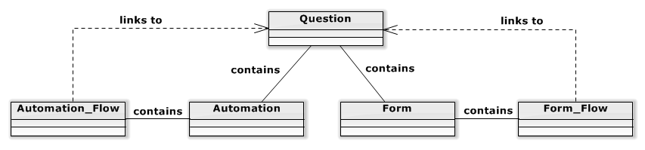

*Figure 5.3-1*

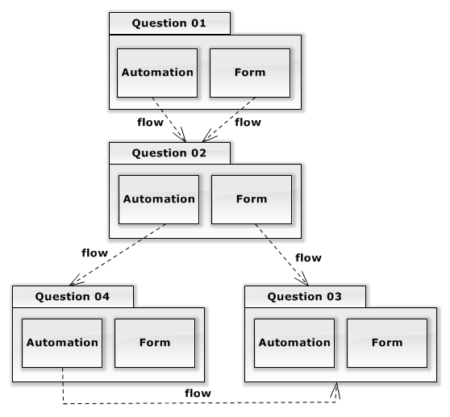

*Figure 5.3-2*

## 5.4 Forms and Automations

Forms are very simple in their concept in that they are simply a list of form_elements. Also, forms contain the form_flow associations. The form is used to display the elements out to the phone application of the user so that they can fill out the survey.

Automations are the counterpart to the form in that they contain a list of commands that will be ran during the Web Driver Automation part of the application. The Automation also contains the associations of the Automation_Flow.

## 5.5 Form Flows and Automation Flows

The way that the form flows and the automation flows act are identical except that they are only ran in different contexts, the form and automation contexts respectively.

The flows can contain one or more relations to the next value. Typically one of the flows will be a default and the other flows will be taking instead if the user inputs a value that would cause the event to take place based on the value inputted. This is how the form_flow works.

The automation flow takes on a different behavior. Basically, it prioritizes all the possible flows. When the action occurs where we need to know whether or not a flow should be taken, it goes by the priority. It checks to see if the question that that flow would take is present in the form_submission object. If there was an answer submitted from the submission, then that means that that question was displayed to the user on the form side and thus the automation process should be performed. If it was not fine, then that means that the question wasn’t displayed, and the automation flow skips to the next prioritized flow option.

## 5.6 Form Elements

Form Elements are added representations of the elements that will be appearing on the Phone of the user for a particular question. The elements can scale dynamically just by adding the code and the logic on the phone application.

Currently there are several types of elements that can be added including:

* Labels
* Textboxes
* Textareas
* Radio Buttons
* Sliding Bars
* Dropdown Boxes

Form Elements contain the following properties, Form Element Attributes and Form Element Options, which will be discussed in more detail next.

### 5.6.1 Form Element Attributes

Form Element attributes are essentially properties that are to be added to the element to give the element certain behaviors when it is displayed. The purpose of this is needed when it comes to needs of how it will appear on the phone, if it dynamically responds to events, and most importantly data validation.

### 5.6.2 Form Element Options

Form Element Options provide a very unique ability to the form elements. In fact, depending on what the element is, the way that the option is used will change. However, the common thread is that they all involve displaying a value out to the user.

Form Element Options contain two properties, the Display_Text which is the text displayed out to the user and the other is the value.

#### 5.6.2.1 Option Value

The value property contains two very distinct possible values. The first type is a text value. Essentially, this is the property that is typed in, such as “YES”. The other is a very special case and that is a reference value. The reference value will contain the Command Element Identification Value inside the Option Value so that it indicates which value it will find.

This value should be formatted however the Identification Type is defined. For instance, if the identification type is XPATH, then the Option value must contain an XPath. If it is IDENTIFICATION, then the option value should be the Id of the Element.

Below is a table explaining what elements follow what pattern:

|  |  |
| --- | --- |
| Element Type | Option Value Behavior |
| Label | None |
| Textbox; Textarea; | Text Value |
| Radio Button; Check Box; Dropdown; Slider; | Reference Value |

#### 5.6.2.2 Display Text

One of the main reasons for separating out the displayed information of the forms is that it gives us the flexibility to provide the feature of using multiple languages in our forms, which as defined in the **Vision and Scope Document** is a huge advantage as it increases the audience base.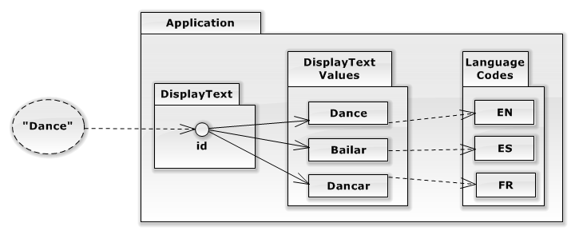

Essentially, the way that the Display Text will be stored is through references. First the text is submitted to the Administrator, and then a new Display Text entry is made. That is the translated into X number of languages. For each translation, the value gets inputted into the Display Text Translation field. Thus when a user wants to see a text in a different language, the language code will be sent in the request. The database will then look at the referenced Display Text and find the translation with the correct language code. Thus, this provides the support for dynamic multi-language support.

## 5.7 Command Elements

Command elements are the counter part to the form elements. The Command Elements are the commands that are performed during the automation of a question.

Command Elements also have two properties, Command Element Identifier and Command Form Element Relation.

### 5.7.1 Identifier

The identifier of the command element is the reference as to how the Web Driver will locate the element on the page in order to perform the action on it.

There are several ways to identify a command element:

* Identification (ID)
* Form Element Name (NAME)
* CSS Class (CLASS)
* XML Path Language (XPATH)

In addition to the identification of the element, the identifier can also contain properties that add behavior to the web driver. The following are the types of behavior

* SKIPPABLE – If the web driver does not immediately find the element, then it will skip over to the next element. The default behavior is that if it cannot find an element prior to the timeout, then it will throw an error and end the automation.
* DEPENDS_ON – is used for elements that depend on SKIPPABLE command_elements. If an element has a Command_Element_Id referenced in the value of the DEPENDS_ON method, and that Command_Element which is SKIPPABLE is skipped, then the DEPENDS_ON Command_Element will not be ran and also skipped over.

Note: That you must list the identifier FIRST and any additional properties should come after.

### 5.7.2 Form Element Relation

The form element relation property is relatively straight forward. This property is needed for any element that relies on the answer of the user. In this case, the Command Element will create a relation to a Form Element so that it identifiers that that is the form_element to use for the value.

During the web driver process, when the command is ran, it will look through the submission answers for the same form_element_id and take the value of that and use it in accordance to that command_type.

8 Data Validation

Currently, the data validation is not implemented at this time for the element, but it is important to address what actions it will need to entail.

## 8.1 Required Fields

Often times, surveys require certain fields to be required, or not left empty. This means that the field is required. When a field is required, then the user cannot continue with the survey until the element contains a value.

## 8.2 Validation of Data

The Validation of the Data is the next aspect needed for the elements. Many times, on surveys, they contain their own validation of value, especially for input values such as textboxes. Because of this, we need to enforce our users to follow the same type of validation by adding these same rules to our application.

### 8.2.1 Numerical

Numerical fields are fields where the user is capable of inputting any value into a textbox, but we can only accept numerical values. This attribute would ensure that the value is a number or integer.

### 8.2.2 Range

This is also applied to a numerical field, but it determines that the value fits inside a specified range.

### 8.2.3 Is one of / is not one of

This type of validation will have the admin specify certain values which are “acceptable” or “not acceptable”. Then the field will ensure that the value that was given follows the specified lists.

### 8.2.4 Format

The ability to determine that a value follows a certain format is critical. It is often used in instances of validating: Dates, Phone Numbers, Social Security, Zip Codes, etc.

The format validation will except a regex pattern that the element will then use to compare that the value given is passes the formula of the regex.